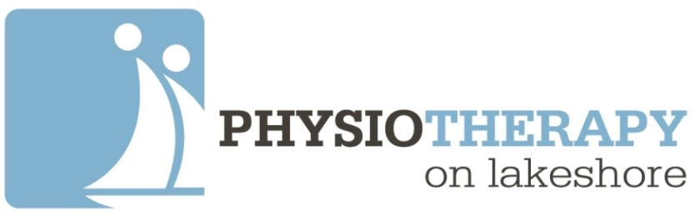

**Meet the Team!**

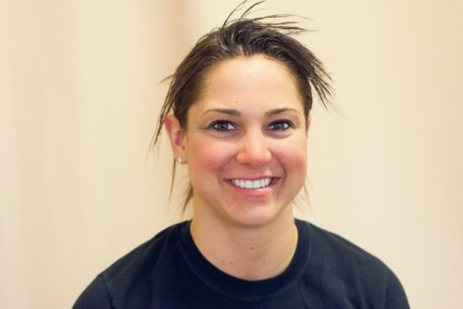

**Stephanie Secord**

**Registered Physiotherapist & Clinic Director**

Stephanie holds a Bachelor of Life Science degree from Queens University and a Masters of Science degree in Physical Therapy from The University of Toronto. She holds advanced professional certifications in the areas of nervous system mobilization, joint mobilization, manual therapy, taping and bracing.  Stephanie has participated in multiple research studies with physicians and physiotherapists and is published in the Journal of Physiotherapy. Stephanie is also a certified personal trainer and an avid competitor in multiple sports including competitive hockey, golf and tennis.

Stephanie’s practice at Physiotherapy on Lakeshore focuses on all Stephanie’s practice at Physiotherapy on Lakeshore focuses on all aspects of muscular skeletal health, including but not limited to injury rehabilitation, chronic pain management, healthy aging, exercise prescription and regaining function and mobility. Stephanie is passionately committed to a client-centered approach. She works with her patients to ensure they receive the necessary knowledge and skills to speed their recovery and prevent secondary injuries from occurring.

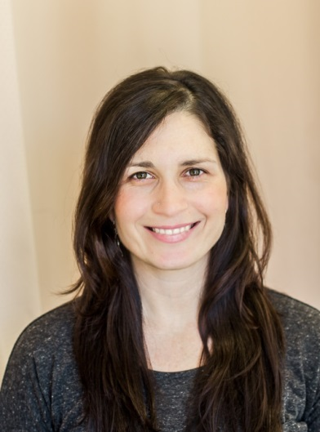**Dr. Jennifer Viveiros**

**Chiropractor & Yoga Instructor**

Dr. Jennifer Viveiros graduated from the Canadian Memorial Chiropractic College in 2007 and obtained her Honours BSc. in Exercise Physiology at McMaster in 2002. Jennifer is an experienced personal trainer and fitness instructor, Zumba instructor, and Yoga teacher. In 2007, Dr. Viveiros travelled to Australia where she worked in various regional areas travelling to small communities to provide chiropractic care and working closely with local football teams. The last 3 years she undertook prenatal and paediatric studies to specialize in infants and children of all ages. In the Sunshine coast she practiced at a prenatal clinic in addition to working with the local Pilates studio and athletic community of the Sunshine Coast. Jennifer has trained in various Chiropractic manipulative/mobilization and soft tissue techniques to treat biomechanical and neurological injuries, including manual, instrument based (Activator), cranial therapy and soft tissue release and neuromuscular techniques.

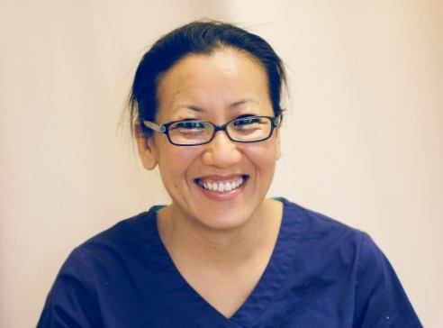

**Iyet Phonphasith**

**Registered Massage Therapist**

Iyet Phonprasith graduated from the Canadian College of Massage and Hydrotherapy in Cambridge and is registered with the College of Massage Therapists of Ontario and a member of the Registered Massage Therapists Association of Ontario.  She specializes in deep tissue massage, trigger point release, post-surgery, MVA’s, stress relief, tendonitis, soft tissue manipulations, Barry Jennings’s myofascial release, sports related conditions and postural dysfunctions related to a typical office setting. Iyet has been active in various sports including Badminton, Ultimate Frisbee, Dodgeball, Rugby and Tae-Kwon-Do. Iyet strives to prepare the most efficient and safe treatment for each individual knowing that everyone has different needs and goals.

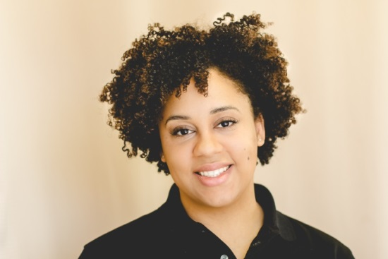

**Melissa Campbell**

**Registered Massage Therapist**

Melissa is a graduate of Everest College of Business, Technology and Health Care. She specializes in Deep Tissue, Swedish Massage and Trigger Point Therapy. She has experience treating motor vehicle, sports and repetitive strain Injuries in a physiotherapy clinic. As a Massage Therapist with an athletic background, she has an interest in muscle balance, assessing and correcting posture and physical habits to reduce pain and improve the ease of daily activities. To continue to advance as a Therapist and acquire new skills, Melissa intends to study Shiatsu Massage and Reflexology.

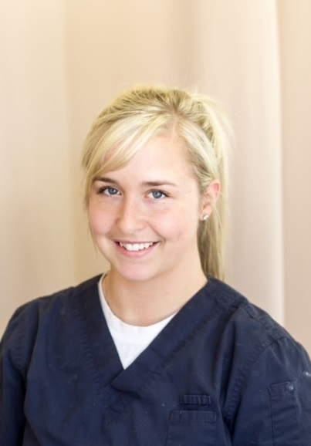**Brittany Noel**

**Physiotherapy Assistant**

Brittany graduated from the National Academy of Health and Business. She started as a volunteer at Physiotherapy on Lakeshore and quickly proved herself to be an asset to the team. Her goal is to help clients learn proper exercise techniques; with the goal of making them more aware of their bodies so as to return safely and quickly to activity. She specializes in manual therapy and making patients smile. To stay active, Brittany likes to play hockey and workout at the gym.